Ideation Phase
Define the Problem Statements
Date: | 29 june 2026
Team ID:
Project name: | Sports hall booking system

Customer Problem Statement
The Sports Hall Booking System is designed to solve the problems faced by students, staff, and sports coordinators when booking sports facilities. Many institutions still use manual booking methods, which lead to double bookings, scheduling conflicts, and delays. This system provides a simple online platform where users can view available halls, reserve time slots, receive booking confirmations, and allows administrators to manage bookings efficiently
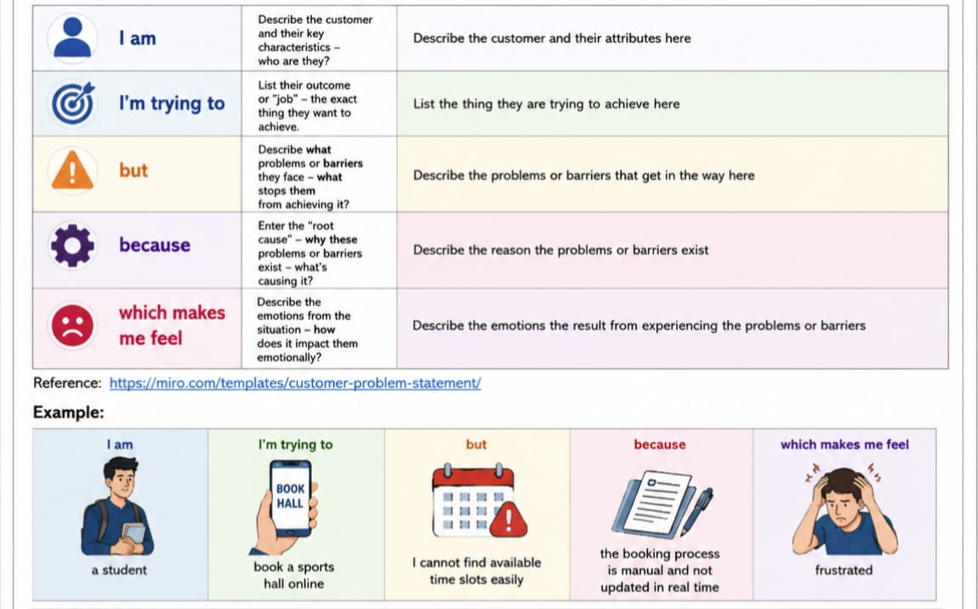

Problem Statement(PS) | Iam (Customer) | I’m trying to | But | Because | Which makes me feel

